ProjectPlanningPhase

**Project PlanningTemplate(ProductBacklog,SprintPlanning,Stories,Storypoints)**

# Product Backlog, Sprint Schedule, and Estimation(4Marks)

Use the below template to create product backlog and sprint schedule

|  |  |  |  |  |  |
| --- | --- | --- | --- | --- | --- |
| **Sprint** | **Functional Requirement(Epic)** | **User Story Number** | **User Story/Task** | **Story Points** | **Priority** |
| Sprint-1 | User Panel | USN-1 | The user will login into the website and go through theproducts available on the website | 20 | High |
| Sprint-2 | Admin panel | USN-2 | The role of the admin is to check out the database about the stock and have a track ofall the things that the users are purchasing. | 20 | High |
| Sprint-3 | ChatBot | USN-3 | The user can directly talk to Chat bot regarding the products. Getthe recommendations based on information provided by the user. | 20 | High |
| Sprint-4 | finaldelivery | USN-4 | Container of applications using docker kubernetes and deployment the application. Create the documentation and final submit the application | 20 | High |

# ProjectTracker,Velocity&BurndownChart:(4Marks)

|  |  |  |  |  |  |  |
| --- | --- | --- | --- | --- | --- | --- |
| **Sprint** | **Total StoryPoint s** | **Duration** | **Sprint StartDate** | **Sprint End Date(Planned)** | **Story Points Completed (as onPlannedEndDat**  **e)** | **Sprint Release Date(Actual)** |
| Sprint-1 | 20 | 6 Days | 24 Oct2022 | 29 Oct2022 |  | 29 Oct2022 |
| Sprint-2 | 20 | 6 Days | 31 Oct2022 | 05Nov2022 |  | 05Nov2022 |
| Sprint-3 | 20 | 6 Days | 07Nov2022 | 12Nov2022 |  | 12Nov2022 |
| Sprint-4 | 20 | 6 Days | 14Nov2022 | 19Nov2022 |  | 19Nov2022 |

**Velocity:**

Imaginewe have a10-daysprintduration, andthevelocityof theteamis20 (pointspersprint).Let’scalculatethe team’saverage velocity(AV)periterationunit(storypointsperday)

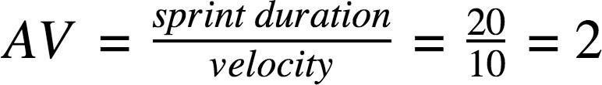

# BurndownChart:

